“Dziadku, wiejemy!” (Granpda, we blow!) – Jan Peszek and Agnieszka Grochowska In the first photos from the new film

Shooting is underway for a new family film directed by Olga Chajdas, with Jan Peszek and Agnieszka Grochowska among others on the set. “Dziadku, wiejemy!” (Granpa, we blow!) is a production that will fill a gap in Polish cinema and tell the story of three generations united by a common adventure. The characters, and with them the audience, will see how much they can learn from each other, how to forgive each other’s weaknesses and accept their own differences, as well as how to handle their emotions. Acting cinematography will be combined with elements of animation. Anna Nowak will play the main child role.

– I dream of creating an Indiana Jones movie for the youngest. I dream of creating a movie like the ones I myself watched as a child. I want to create something that shows in good, cinematic form what is most important for children now. I want to take them seriously – as viewers and as partners who go to the cinema,” says Olga Chajdas.
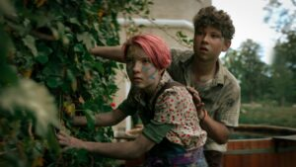
The film will enter theaters in 2025.
– Amazing adventures can also be had with your own family. All you have to do is set out on the road. In our film, Jan Peszek plays a crazy grandfather and Agnieszka Grochowska plays a mother who is just learning to have fun. And between them is 10-year-old Jagoda. This is real cinema for the whole family – everyone will find a story for themselves,” says producer Malgorzata Malysa.
Jan Peszek adds: – I hope it will be a film that is completely unpredictable, wild, for every generation. The granddaughter runs away with her grandfather – from what and why you will find out from the film itself.
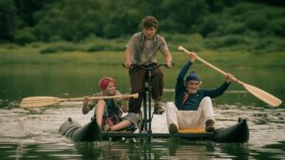

ABOUT THE FILM “DZIADKU, WIEJEMY!” (GRANDPA, WE BLOW!)
One day Grandpa Jeremi causes such a commotion in the retirement home that he is threatened with transfer to a psychiatric hospital. Marta, his daughter, agrees to take him in, although this is difficult for her, since Jeremi is unpredictable and has a vivid imagination. The situation is complicated by Jagoda, Marta’s daughter, who adores her grandfather and shares his crazy ideas. When Jeremi refuses to live with the family, Jagoda decides to take matters into her own hands. The girl and grandfather embark on an adventurous journey to the legendary ship Light of the Sea. In pursuit of them moves a gang of villains led by the rich man Waldemar and the terrified mother of Jagoda. Well, and the dragon – a dragon also goes after them.
“Dziadku, wiejemy!” (Granpa, we blow!) is a humorous and warm film about family, adventure and the magic of imagination.
The role of Jagoda will be a debut for Anna Nowak. The role of her grandfather Jeremy will be played by Jan Peszek, her mother will be played by Agnieszka Grochowska. The other roles are played by Michal Majnicz, Wlodzimierz Press, Wiktor Zborowski, Sonia Roszczuk, among others.
The author of the script is Emil Ploszajski. Bartosz Bieniek is responsible for the cinematography. The producers of the film are Malgorzata Malysa and Karolina Galuba of Furia Film. Distribution will be handled by NEXT FILM. Co-producers are: Fale Loki Koki, Moderator Investments, Abstraction Plan, Aneta Graff – Dabrowska, EC1 Lodz – City of Culture, Lower Silesian Film Center, Institute of Urban Culture operator Gdansk Film Fund. The film received a grant from the Polish Film Institute.
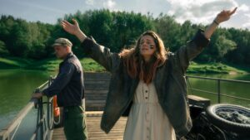
GRANDPA, WE BLOW!
directed by: Olga Chajdas
screenplay: Emil Płoszajski
cinematography: Bartosz Bieniek
set design: Marcelina Początek-Kunikowska
costumes: Anna Englert
make-up: Ewa Szwed
cast direction: Paulina Krajnik
editing: Pavel Hrdlicka
sound: Jaroslaw Bajdowski, Grzegorz Kucharski
music: Smolik
producer: FURIA FILM Karolina Galuba, Małgorzata Małysa
production manager: Małgorzata Banaszkiewicz
production: Furia Film
distribution: NEXT FILM
co-production: Fale Loki Koki, Moderator Investments, Abstraction Plan, Aneta Graff – Dąbrowska, EC1 Łódź – City of Culture, Lower Silesian Film Center, Institute of Urban Culture operator Gdansk Film Fund
co-financed by: Polish Film Institute
FILM PRODUCED IN POLAND WITH FINANCIAL SUPPORT UNDER THE ACT ON FINANCIAL SUPPORT FOR AUDIOVISUAL PRODUCTION, GRANTED BY THE POLISH INSTITUTE OF FILM ART FROM THE FUNDS OF THE MINISTRY OF CULTURE AND NATIONAL HERITAGE



