See the poster of “KogelMogel 4 [Eggnog 4]” and meet the new characters
– I want the audience to fall in love with Marlenka’s mother – says Dorota Stalińska, who stars as a new character of “Kogel Mogel [Eggnog]” and creates an unforgettable duo with Katarzyna Skrzynecka. Other actors we will see on the screen include, among others, Marian Opania and Karol Strasburger. “Koniec świata czyli Kogel Mogel 4 [The End of the World. Eggnog 4]” will hit the big screen on the 7th of January.
– I play an ageing Don Juan, a fraudster looking for a rich woman – says Marian Opania. – The script is really well-written, I loved it from the very beginning – he adds.
Grażyna Błęcka-Kolska will play the role of the legendary Kasia Zawada for the fourth time: – The first parts of “Kogel Mogel [Eggnog]” were filmed about 30 years ago. Since then, we have all changed. I am no longer the same Kasia, I am no longer 20. I am really happy that this enormous audience that so appreciated previous parts of the film and was really looking forward to the sequel will finally get to see the fourth part. For me, as an actor, it is a great opportunity to play a slightly older character. Kasia has a son, her mother has got old, and the world has changed – it is an interesting role to play and share with the viewers.
There is also much going on in the lives of the younger characters of “ Koniec Świata [The End of the World]” – there is a marriage proposal, but there are problems as well. The relationship of Marcin (Nikodem Rozbicki) and Agnieszka (Aleksandra Hamkało) is put to the test because of the heartbroken lover, Bożenka (Anna Mucha).
Aleksandra Hamkało comments on the character she plays: – The life of Agnieszka in “Kogel Mogel 4[Eggnog 4]” is different from the one presented in the previous part. She has to face completely new challenges, and I have a feeling, that she has also changed a little bit. Not too much, though, as she is still a funny character – a little bit of a goof and a drama queen. She has this incredible ability to create chaos everywhere she goes.

See the film trailer

KONIEC ŚWIATA CZYLI KOGEL MOGEL 4 [THE END OF THE WORLD. EGGNOG 4]

The love of Agnieszka and Marcin flourishes, just like the feeling between Kasia and professor Wolański. Grandma Solska dreams only about the wedding of her only grandson… But the happiness of the young Zawada boy is interrupted by his old lover, Bożenka. Wolańska decides to completely change her life and disappears in mysterious circumstances. The peace of Piotruś and Marlenka is disturbed by an unexpected visit of a mother from overseas… And some very embarrassing photos kick off a series of events. We will witness the real end of the world!

The cast of the fourth part of “Kogel Mogel [Eggnog]” once again includes: Nikodem Rozbicki, Aleksandra Hamkało, Grażyna Błęcka-Kolska, Ewa Kasprzyk, Zdzisław Wardejn, Katarzyna Skrzynecka, Maciej Zakościelny, Anna Mucha, Katarzyna Łaniewska, Paweł Nowisz, Małgorzata Rożniatowska, Wiktor Zborowski, Joanna Jarmołowicz and Wojciech Solarz. They were joined by (among others): Dorota Stalińska, Marian Opania and Karol Strasburger.

The previous part of the series, i.e. “Miszmasz czyli Kogel Mogel 3 [Eggnog 3]”, was seen in the cinemas by almost 2.4 million viewers. “Koniec świata czyli Kogel Mogel 4 [The End of the World. Eggnog 4]” was directed by Anna Wieczur. It was produced by MTL Maxfilm. The film was co-financed by the Polish Film Institute.

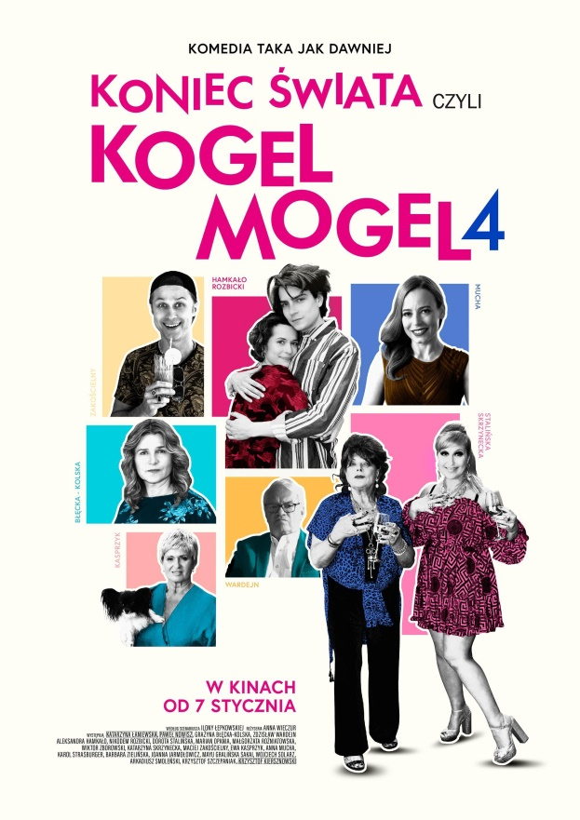
Premiering on: 7 January 2022
Cast: Nikodem Rozbicki (Marcin), Aleksandra Hamkało (Agnieszka), Grażyna Błęcka-Kolska (Kasia), Ewa Kasprzyk (Wolańska), Zdzisław Wardejn (Wolański), Katarzyna Skrzynecka (Marlenka), Maciej Zakościelny (Piotruś), Dorota Stalińska (Marlenka’s mum), Anna Mucha (Bożenka), Katarzyna Łaniewska (Solska), Paweł Nowisz (Goździk), Małgorzata Rożniatowska (Goździkowa), Wiktor Zborowski (county head), Joanna Jarmołowicz (policewoman), Wojciech Solarz (policeman), Mayu Gralińska-Sakai (Mary), Marian Opania (Leopold Kapusta), Karol Strasburger (Kazimierz Janik)
Director: Anna Wieczur
Screenplay: Ilona Łepkowska
Cinematography: Jan Cybis
Set design: Katarzyna Piąstka
Editing: Marceli Majer GMP
Costumes: Anna Męczyńska
Make up: Janina Dybowska-Person
Music: Atanas Valkov, Krzysztof A. Janczak
Sound: Adam Szmit, Kacper Habisiak MPSE, Marcin Kasiński MPSE
Producer: Tadeusz Lampka, Ilona Łepkowska
Production: MTL Maxfilm
Distribution: Next Film
Co-financing: The Polish Film Institute

CONTACT DETAILS FOR THE PRESS:
Joanna Jakubik
joanna.jakubik@next-film.pl
phone No.: 514 793 494

