“Black sheep” in cinemas as of 13 August. Watch now the teaser trailer for the film by Aleksander Pietrzak.

Magdalena Popławska, Arkadiusz Jakubik and Kamil Szeptycki in a film about a family whose every member is put to the test. Sometimes, a single word can bring about a series of consequences, and one decision can change the fate of an entire family... Still, changes do not always have to be bad, do they?
In the film, apart from recognised and established actors, we will see talented representatives of the younger generation. Tomek, a popular youtuber, is played by Kamil Szeptycki. He is the one to tell the story of the Gruz family, and his comments accurately reflect upon the important events in the life of the family.
In the film, we will see a few people known to YouTube and Instagram fans, such as Cyber Marian, Danny Ferreri, Dziki Trener, Martyna Pysia or Kinga Sawczuk.
“Black sheep” will hit the in cinemas on 13 August.
/teaser trailer link/

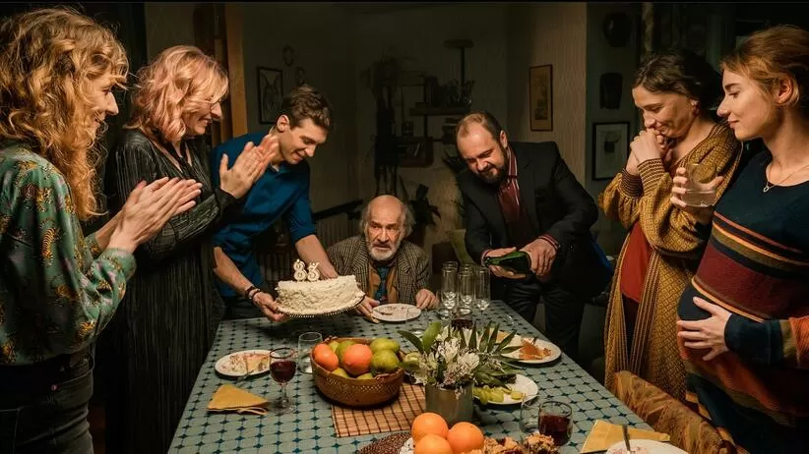
Photo: Jarosław Sosiński

“Black sheep” is a bitter-sweet story about a modern family where everybody is fed up with something. When troubles, conflicts and desires that have been repressed for many years finally explode, everybody starts to live their own life. Or at least they think they do… Will they find their path to happiness? It is a film about bonds that are impossible to break. It gives humorous answers to many important questions regarding family relations and growing up.

Aleksander Pietrzak, director:
The film touches upon many topics, such as the choice between career and family, growing into the role of a father, the problems with finding yourself in a completely new life situation, but it mostly deals with the fact that when a child makes bonds, they last forever. Laughter and crying are the two most beautiful emotions. This is exactly what we get from a comedy drama and, hopefully, will also get from “Black Sheep”.

Anna Waśniewska-Gill, producer:
It is a universal story about growing up that everyone can identify with. It humorously depicts the intergenerational differences, problems caused by miscommunication and the fear of showing your true feelings. We wanted to show the truth about a family and different moments in the life of a small community. Funny moments, but sometimes also sad and scary ones. After the really difficult experience that we all have been sharing for a year now, we are aware that people long for positive emotions, and we are sure that “Black Sheep” by Alek Pietrzak can evoke such emotions.

“Black Sheep”
in cinemas as of 13 August 2021

Cast: Arkadiusz Jakubik, Magdalena Popławska, Kamil Szeptycki, Agata Różycka, Anna Cieślak, Anna Smołowik and Włodzimierz Press
Director: Aleksander Pietrzak
Screenplay: Bartosz Kozera
Cinematography: Mateusz Pastewka
Casting director: Marta Kowacka
Producer: Anna Waśniewska-Gill
Executive producer: Rafał Ulicki
Production: TVN Discovery Group

CONTACT DETAILS FOR THE PRESS:
Agata Wojciechowska
agata.wojciechowska@next-film.pl, tel. 504 289 058

