“Autumn Girl” – poster and first teaser of a film about the scandal queen of the Polish cinema

“She never felt ashamed, that was just the way she was” – says Katarzyna Klimkiewicz, the director of “Autumn Girl” when talking about Kalina Jędrusik. The legendary Polish sex symbol was portrayed by Maria Dębska. This long-expected film is coming out in cinemas on 12 November. It will be screened before the official release during the New Horizons Film Festival in Wrocław and at the Main Competition of the Polish Film Festival in Gdynia. We present you with the poster and first film teaser of “Autumn Girl”.
Watch the teaser
The biggest sex symbol of the Polish People's Republic
Warsaw, the 1960s. Millions of Poles sit in front of their black-and-white TV screens.
Suddenly, someone appears and draws their attention. It is Kalina Jędrusik (Maria Dębska) – a phenomenal actress and singer who brings colour into this grey, dreary reality. She shines with her grace and sex appeal, leaving men electrified and women outraged. She is the first sex symbol in the Polish People's Republic, the Polish Marilyn Monroe.
Kalina refuses to give in to what is expected of women in her times. She lives by her own rules, and this is not always appreciated by the prudish society and certain influential people in power. She is involved in many scandals, lives in a ménage à trois with her husband, Stanisław Dygat (Leszek Lichota) and Lucek (Krzysztof Zalewski), makes controversial statements and wears outfits that radiate sex appeal, causing her to become one of the most controversial figures in the Polish People's Republic. And yet, the biggest scandal in her career is still to come…
“Autumn Girl” depicts an important part of the life of Kalina Jędrusik, who is obviously one of the biggest icons of the Polish pop culture. It is a story of the highs and lows of her turbulent career, her proudest and most embarrassing moments. Her own story is accompanied by the bigger picture – the wild parties of the cream of the contemporary society.
The cast will also include other landmark figures of the Polish cultural scene: Kazimierz Kutz (Borys Szyc), Tadeusz Konwicki (Paweł Tomaszewski) or founders of the Elderly Gentlemen's Cabaret – Jeremi Przybora (Rafał Rutkowski) and Jerzy Wasowski (Dariusz Basiński).

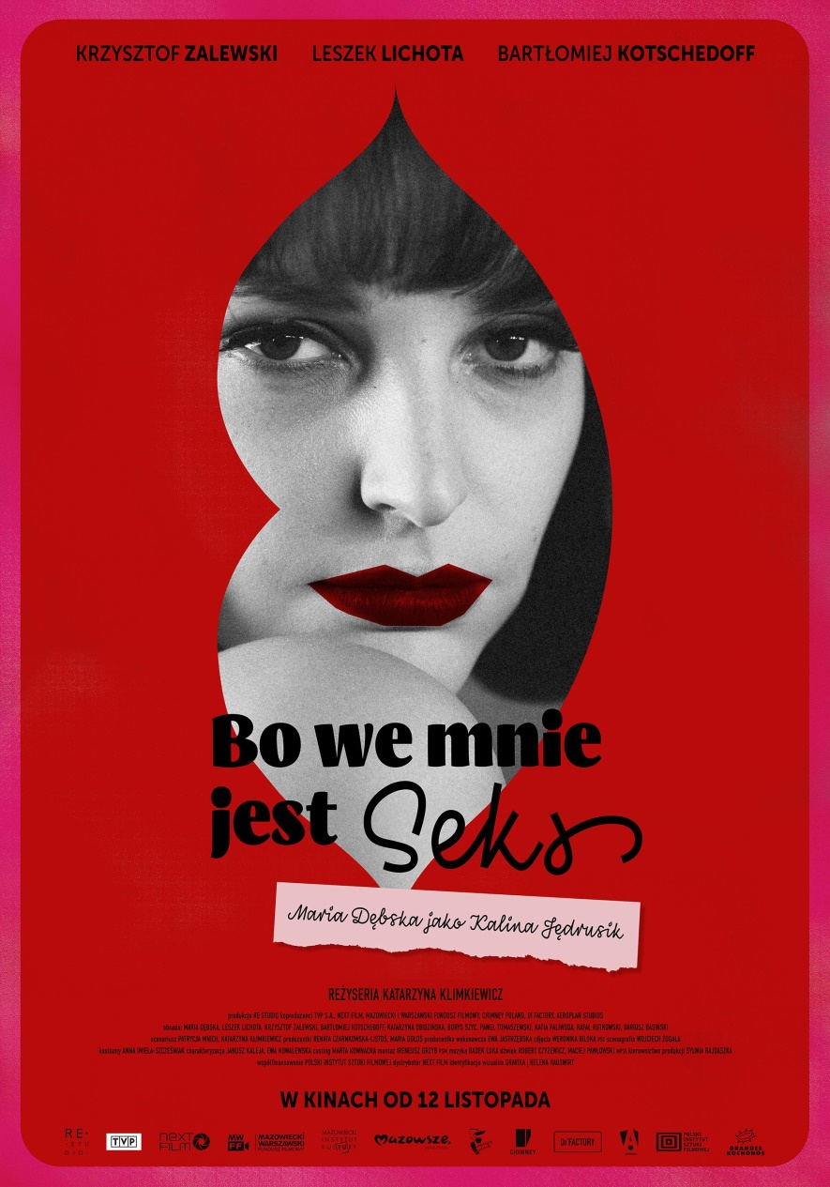
The poster was prepared by GRAVIKA | Helena Hauswirt.

The dazzling 1960s.

– We made everything we could to make sure that the world shown on the screen seemed very real. The cinema-goers should want to find themselves on the other side of the screen and enjoy a sip of vodka – says Maria Dębska. – It is wonderful that the sixties are not shown to be dreary, rainy or foggy; instead, they dazzle you with their lights, neon glow and bewitching charm – she adds.
The protagonist of “Autumn Girl” was a symbol of sex appeal, independency, rebellion and joie de vivre. She was a nonchalant woman who would not be bothered just because she made the wrong impression on someone. She was not afraid to outrage people or cause controversy, and she did not much care if anyone did not like what she was doing – says Katarzyna Klimkiewicz.
Pre-release screenings
The first pre-release screenings of the film are scheduled to take place already this August. The film will be shown at the New Horizons International Film Festival in Wrocław (12–22 August). In September, “Autumn Girl” will try for the Golden Lions in the Main Competition of the Polish Film Festival in Gdynia (20–25 September).

***
“Autumn Girl”
Premiering on: 12 November

Cast: Maria Dębska, Leszek Lichota, Krzysztof Zalewski, Bartłomiej Kotschedoff, Borys Szyc, Katarzyna Obidzińska, Katia Paliwoda, Paweł Tomaszewski, Rafał Rutkowski, Dariusz Basiński

Director: Katarzyna Klimkiewicz
Screenplay: Patrycja Mnich, Katarzyna Klimkiewicz
Production: RE Studio, Renata Czarnkowska-Listoś, Maria Gołoś
Co-production: Telewizja Polska, Next Film, Mazowiecki i Warszawski Fundusz Filmowy, Chimney Poland, DI Factory, Aeroplan Studios
Co-financing: Polish Film Institute
Executive producer: Ewa Jastrzębska
Cinematography: Weronika Bilska
Set design: Wojciech Żogała
Costumes: Anna Imiela-Szcześniak
Make-up: Ewa Kowalewska, Janusz Kaleja
Casting director: Marta Kownacka
Sound: Robert Czyżewicz, Maciej Pawłowski
Music: Radek Luka
Editing: Ireneusz Grzyb
Production management: Sylwia Rajdaszka
Image post-production: DI Factory
Visual effects: Chimney Poland
Sound post-production: Aeroplan Studios
Visual identification: GRAVIKA | Helena Hauswirt

Distribution: NEXT FILM
Promotion coordination: Grandes Kochonos
International Sales Agent: Izabela Kiszka-Hoflik, IKH – Pictures Production & Promotion
CONTACT DETAILS FOR THE PRESS:

Joanna Jakubik
joanna.jakubik@next-film.pl
phone No.: 514 793 494
Karolina Sienkiewicz
k.sienkiewicz.film@gmail.com
phone No.: 600 271 634
www.next-film.pl
youtube.com/nextfilmpl
facebook.pl/nextfilmpl

